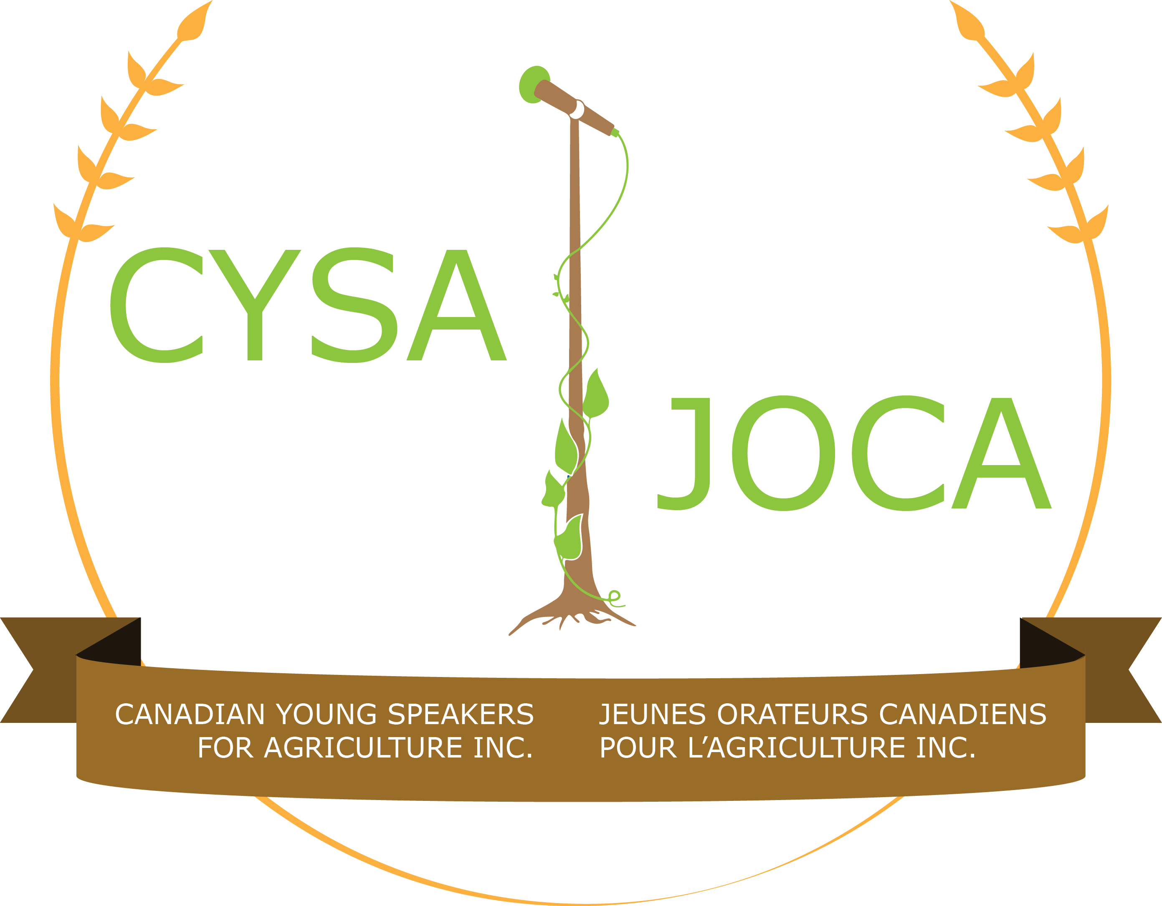 For Immediate Release

Canadian Young Speakers for Agriculture Announces
2022 Competition Topics

February 28, 2022, Guelph, Ontario – Canadian Young Speakers for Agriculture (CYSA) is excited to announce the 2022 public speaking competition topics:

- The implications of supply chain issues on Canada’s food supply.
- Rising global water and temperature levels: What does it mean for agriculture?
- Unexpected careers: Here are three jobs you didn’t know were linked to agriculture.
- Alternative agriculture: What opportunities await Canadian farmers?
- Is local food sustainable?
- Why the world is eating more fish and what it means for Canadian aquaculture.
- I realized I wanted a career in agriculture when _______.

“After two years of uncertainty, CYSA anticipates a return to an in-person competition at the Royal Agricultural Winter Fair,” says CYSA President April Stewart. “Our 2021 competition was held virtually and while we had great participation and the usual high caliber of competitors, we know that speakers have missed everything that an in-person event at such an historical venue has to offer. And our board has certainly missed the face-to-face interactions with competitors as well.”

Since the first competition held at the Royal Winter Fair in honour of the International Year of the Youth in 1985, CYSA has gone on to become the premier public speaking event in Canada for young people interested in agriculture, with more than 1000 participants over the years. For more information about CYSA visit www.cysa-joca.ca

Watch CYSA’s social media channels (Twitter: @CYSAgriculture, Facebook: facebook.com/CYSA.JOCA, Instagram: Instagram.com/cysa.joca) for updates about the 2022 competition and other interesting opportunities from industry partners throughout the year.

-30-

For more information, please contact:
Ted Young | CYSA Chair
519-546-5053 or tedyoung@sympatico.ca

